GROUP EXPENSE LOGGER
@CREATIVITY THINK (9483175986/7019689991)

ABSTRACT:
Group Expense Logger is a web-based application designed to help groups such as flatmates, students, and families manage shared expenses efficiently. The platform allows users to create groups, log expenses, track individual contributions, split costs automatically, and monitor payments. Administrators can manage groups, moderate logs, and generate analytics through dashboards. Developed with Django and Django Rest Framework for the backend and React with Redux and Recharts for the frontend, the system ensures transparency, accuracy, and simplicity in handling shared finances, offering users and admins a centralized solution for expense management..

INTRODUCTION OF THE PROJECT:
Managing group expenses can often become cumbersome, especially when multiple members contribute at different times. Traditional methods, such as spreadsheets or manual tracking, are prone to errors and lack transparency. Group Expense Logger addresses these issues by providing a centralized platform to log, track, and split expenses, ensuring fairness and accountability. Users can see up-to-date balances and payment statuses, while administrators can oversee groups, moderate logs, and generate insights through dashboards. This system improves financial coordination, reduces disputes, and makes expense tracking effortless..

PROJECT OBJECTIVES:

• Enable users to create and manage expense groups
• Allow logging of shared expenses with automated split calculations
• Track payments and outstanding balances for group members
• Provide dashboards to visualize group spending and member contributions
• Allow administrators to manage groups, members, and logs
• Moderate expense entries to ensure accuracy and fairness
• Offer secure and scalable backend APIs for data processing
• Support exporting analytics and reports for financial tracking

PROBLEM OF THE STATEMENT:
Groups often face difficulties in tracking shared expenses due to inconsistent record-keeping, delayed payments, and lack of transparency. Manual tracking methods are prone to errors and disputes among members. Administrators have limited visibility into group spending and member contributions. Group Expense Logger solves these problems by automating expense tracking, splitting, and payment monitoring, ensuring transparency, accountability, and accurate financial management for all group members..

MOTIVATION OF THE PROJECT:
• To simplify shared expense tracking for groups
• To prevent disputes by automating expense splitting
• To provide transparency through real-time dashboards
• To reduce manual effort and errors in financial tracking
• To enable administrators to moderate entries and manage groups efficiently
• To provide analytics for better understanding of group spending
• To enhance accountability and streamline group financial management

BLOCK DAIGRAM OF PROJECT:

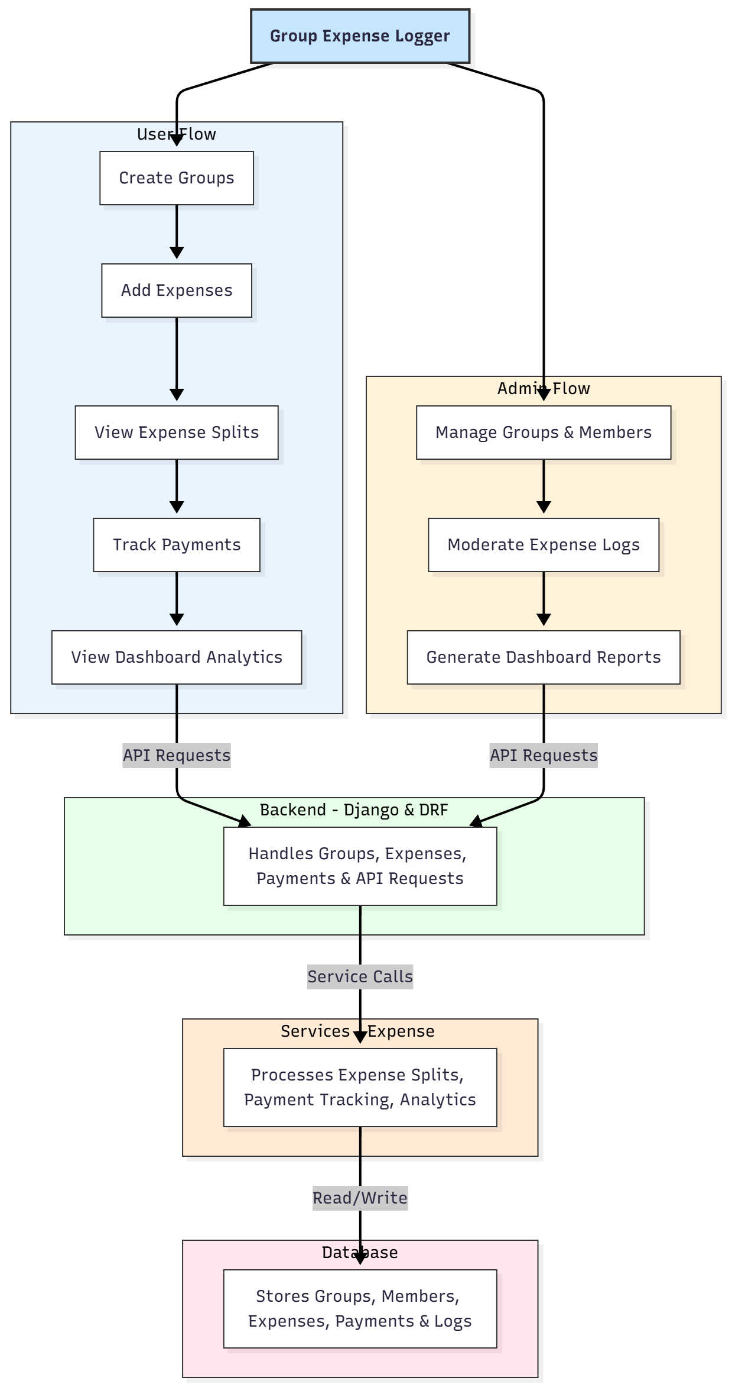

WORKING OF THE PROJECT:
Users start by creating groups and adding members. They log expenses within the group, specifying the amount and contributors. The system automatically calculates each member's share and tracks payments. Users can view balances and outstanding payments in real-time dashboards. Administrators manage groups and members, moderate expense logs to ensure accuracy, and generate detailed reports using the analytics module. The backend handles API requests, expense calculations, and payment tracking, while the database securely stores all group, expense, and user data. This ensures transparency, accountability, and smooth financial management..

SOFTWARE REQUIREMENT:
- Backend:
  - Python 3.x
  - Django
  - Django REST Framework
  - SQLite/PostgreSQL
- Frontend:
  - Node.js and npm
  - React.js
  - Axios
- Development Tools:
  - Visual Studio Code
  - Postman (for testing APIs)
  - Git/GitHub (for version control)
- Server/Deployment (Optional):
  - Gunicorn, Nginx, or Heroku/AWS for hosting

ADVANTAGES OF THE PROJECT:

• Simplifies tracking of shared expenses
• Automates expense splitting and payment calculations
• Reduces disputes and ensures transparency
• Provides real-time dashboards for users and admins
• Enables efficient group and member management
• Offers analytics for financial insights
• Improves accountability among members
• Scalable for small and large groups

APPLICATIONS OF THE PROJECT:
• Flatmates managing shared household expenses
• Student groups for trips or projects
• Families tracking shared budgets
• Clubs and community groups
• Small teams coordinating shared purchases

REFERENCES:

- Django REST Framework Documentation — Django Software Foundation. Django Documentation. Available: https://docs.djangoproject.com/
- Django REST Framework. DRF Documentation. Available: https://www.django-rest-framework.org/
- React. React Official Documentation. Available: https://reactjs.org/docs/getting-started.html
- Redux. Redux Documentation. Available: https://redux.js.org/introduction/getting-started
- PostgreSQL Global Development Group. PostgreSQL Documentation. Available: https://www.postgresql.org/docs/
- MySQL. MySQL Reference Manual. Available: https://dev.mysql.com/doc/
- Git. Git Documentation. Available: https://git-scm.com/doc
- Node.js. Node.js Documentation. Available: https://nodejs.org/en/docs/
- Axios. Axios Documentation. Available: https://axios-http.com/docs/intro
- Socket.io Documentation – https://socket.io/docs/

